Life-Size Character Map
Trace yourself on a piece of butcher paper. Label your paper in accordance with the diagram below for a character of your choosing from To Kill a Mockingbird. You will want to choose a character you relate well to, possibly the one you wrote about in your journal.
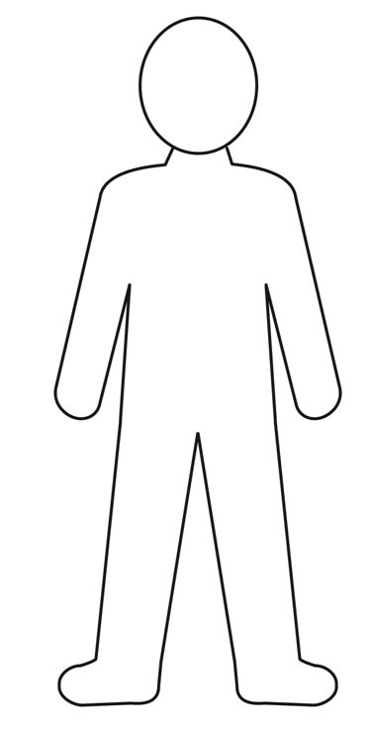
*Use direct quotes from the book to support your assertions.
*Please make this look nice! Use markers and crayons to color your character.
How would you describe this character?
What are their character traits?
What is the character’s problem? How do they solve this problem?
What are the character’s actions?
How does the character change over the course of the story?
What is this character’s relationship with other characters?
How is he/she related to other characters and how do they interact?
How does this character react emotionally to events?
What do they say and what do they do?

