TKAM Opinionaire: Day 1 and 20
Name: Date:
To begin our study of To Kill a Mockingbird, you will state and support your opinions on key topics related to the novel. In the chart below, you must indicate whether you strongly agree, agree, disagree, or strongly disagree with each of the 11 statements. Then, you must support your position with a clear explanation and detailed examples.

 | Opinion  (Strongly Agree, Agree,  Disagree, Strongly Disagree) | Explanation  (Why do you feel this way? What examples from your life support your position?)
All men are created equal.
Girls should act like girls.
When the law does not succeed in punishing criminals, citizens should do so.
It is okay to be different.
Education makes everyone equal.
No one is above the law.
Some words are so offensive that they should never be spoken or written.
Speaking standard English and grammar proves an individual’s intelligence.
Nobody is all good or bad.
Under our justice system, all citizens are treated equally by the court of law.
A hero is born not made.
Historical Context: The Civil Rights Movement
As Harper Lee was writing this novel, the Civil Rights movement was just beginning. The following events impacted Lee’s writing and the rest of the nation
1954- The Supreme Court strikes down the Plessy vs. Ferguson decision which favored segregation. Instead they approve the integration of public schools in the Brown vs. the Board of Education case.
1955- Rosa Parks is arrested on December 1st for violating the bus segregation ordinance in Montgomery, Alabama. Four days later the famous bus boycott begins.
Jan 1956- Martin Luther King, Jr.’s house is bombed.
1955-56- Arthrine Lucy, a black woman, attempts to enroll in the University of Alabama as a student. Following months of litigation, she is forced to withdraw after mobs of whites riot on the campus.
Feb 1956- A petition started by a small group of students and professors asks for the return of Arthrine Lucy to campus.
Feb 22nd, 1956- 115 persons are indicted for taking part in the bus boycott.
Feb 24th, 1956- A massive rally is held by African Americans in Montgomery to plan a day of walking and praying.
1956- The bus boycott ends on December 21, and busses are intergrated.
1957- Martain Luther King, Jr., Charles K. Steele, and Fred Shuttlesworth establish the Southern Christian Leadership Conference which is instrumental in organizing the civil rights movement.
1960- To Kill A Mockingbird is published.

Historical Context Handout, day 1
Possible Scenes, day 2
- School scene: Walter Cunningham with no lunch money
- The Ewells’ House: A depiction of their home
- The children acting out a play about Boo Radley
- The Mob Scene: Scout asking questions
- Calpurnia taking the children to church

Urban Legends People and Places Photos, day 3 and 4
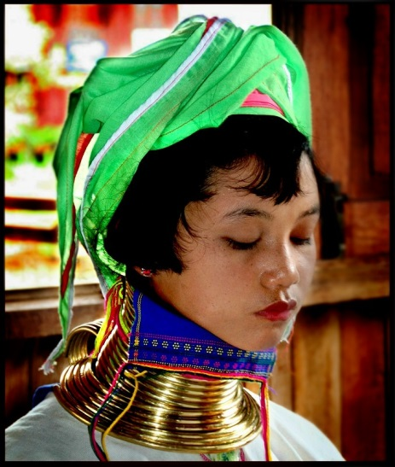
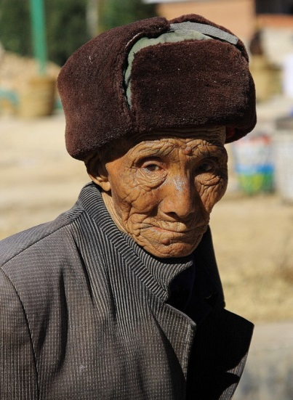
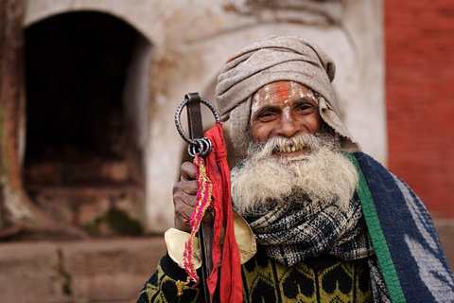
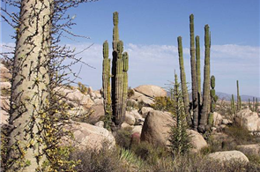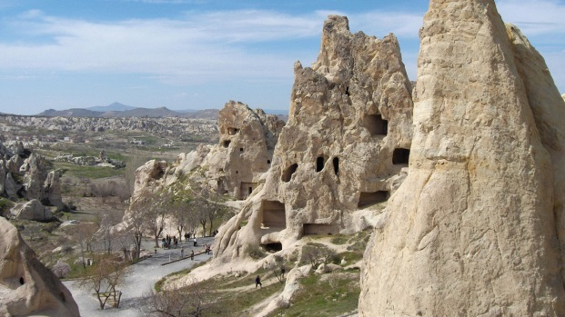

How Urban Legends Work
Popular culture and urban legends are often closely related. Old legends end up as plot points in movies, and fictional elements from movies are circulated as real-life tales. In the latter case, somebody might start the legend because it's more exciting to say that an event really happened than that it happened in a movie. Or maybe the person simply forgot where he or she actually heard the story.
Many people believe an urban legend must be true because it is reported by a newspaper, or other "authoritative source." Journalists, police officers and other authorities do get things wrong from time to time, and most of them openly admit this. There is no infallible source of information.
Just about anybody can be duped into believing an urban legend because very few people distrust everything and everybody. Most of us don't investigate every single piece of information we hear -- for efficiency's sake, we accept a lot of information as truth without looking into it ourselves. Psychologically, we need to trust people, just for our own sense of comfort. And if you trust somebody, you'll believe almost anything that person tells you.
In many cases, this trust runs so deep that a person will insist that an urban legend actually occurred, even when confronted with evidence to the contrary. Urban-legend Web sites like Snopes.com get a lot of e-mail from readers who are outraged because the site is calling their friend a liar.
Another reason such stories get passed on is because the details make them seem real. You may have heard stories of children being kidnapped from a specific location of a local department store, or you may have heard about various gang initiations (more on this later) that occurred in a specific part of your town. Since you are familiar with the setting -- you know it's a real place -- the story sounds real. This level of specificity also plays into your own fears and anxieties about what could happen to you in the places you visit regularly.
Urban legends are spread in cultures all over the world. In these diverse regions, the familiar elements of horror, humor and caution show up again and again, though the specific themes vary. In the next section, we'll explore the significance of urban legends to find out what these persistent themes might say about the societies we live in.

Day 3 and 4

Poetry worksheet, day 6
cockroach (kok' roch'), n. any of an order of nocturnal insects, usually brown with flattened oval bodies, some species of which are household pests inhabiting kitchens, areas around water pipes, etc. [Spanish cucaracha]

Answer individually…
- What does the word cockroach mean to you?

- Is a cockroach merely an insect or is it also a household nuisance and a disgusting creature?

Read and annotate your poem. Then, reread the dictionary definition of cockroach.
With your partner…
- Which of the denotative characteristics of a cockroach is included in the poems?

- What characteristics does the author give the roaches that are not in the dictionary definition?

With your group…
- Which characteristics of cockroaches are expressed in both poems?

- Which poet comes closer to expressing your own feelings about roaches
Bird Thinking Map, day 8 and 9

Bird:

Character:

Character List Worksheet, day 10
Character | Physical Description | Description of their traits
Jean Louise “Scout” Finch
Jeremy “Jem” Finch
Atticus Finch
Arthur “Boo” Radley
Dill Harris
Maudie Atkison
Calpurnica
Henry Dubose
Walter Cunningham
Bob Ewell
Aunt Alexandria
Mayella Ewell
Tom Robinson
Link Deas
Nathan Radley
Mr. Heck Tate
Dolphus Raymond

Charade Strips, day 11
Atticus: Tom Robinson was found guilty
Bob Ewell: The trial

Scout: The mob coming to shoot Tom in his jail cell while Atticus is protecting him him
Jem: Calpurnia takes Jem and Scout to church

Jem: Atticus shooting the dog
Scout: Miss Maudies house burnt down

Boo: Jem and Scout are attacked by Mr. Ewell
Tom Robinson: The trial

*Inferring a Character’s Emotions activity. Cut along lines and have students draw a slip of paper. Students will read the event a loud and act out the bolded character’s emotional reaction to the stated event. Other students will guess the emotion.
Character Map Sheet, day 12
Life-Size Character Map
Trace yourself on a piece of butcher paper. Label your paper in accordance with the diagram below for a character of your choosing from To Kill a Mockingbird. You will want to choose a character you relate well to, possibly the one you wrote about in your journal.
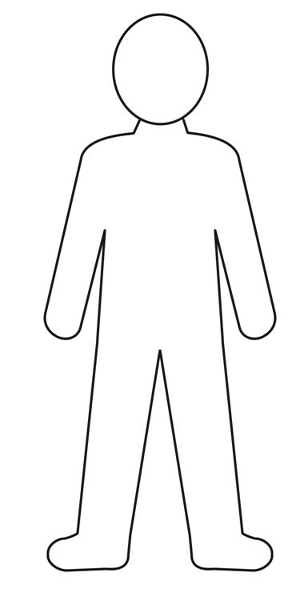
*Use direct quotes from the book to support your assertions.
*Please make this look nice! Use markers and crayons to color your character.
What are the character’s actions?
How does the character change over the course of the story?
How does this character react emotionally to events?
What do they say and what do they do?
How would you describe this character?
What are their character traits?
What is the character’s problem? How do they solve this problem?
What is this character’s relationship with other characters?
How is he/she related to other characters and how do they interact?

Roles of the Court
Judge- will preside over the trial, instructs and Vior Dires the Jury, make rulings on points of law, and have general charge over the proceedings of the trial and its participants.
Parties- they are the prosecutor, the Defense Attorney and the defendant.
Attorneys- participate in trials as advocates for the parties in the Trial.
Witnesses- present testimony under oath concerning what they have seen or know about the facts of the case.
Prosecuting Attorney- is the official representing the School or County in a trial.
Court Clerk- logs all trial proceedings and will be responsible for preparing Documents of the trial and Swears in the Jury and Witnesses.
Court Bailiff- opens court and is responsible for maintaining order and security in the courtroom and protecting the jury form outside interference when they are deliberating.
Defense Attorney- is the official representing the Defendant in a trial. (Usually in a team of two members.)
Parts of a Trial
The Opening- This where a good Attorney can “win” the Trial. It should have the theory as to be why the offense happened. It should include the basic facts of the case that will be proved during the Trial. The Attorney is trying to get the Jury to like his/her client and the Attorney as well, so it is important to paint picture that makes the Jury identify with the Attorney’s point of view (and be sympathetic for the Defendant.) The Opening Statement is a great opportunity to preempt any argument of the opposing Attorney. However it is thin tightrope to walk, the Opening is about letting the Jury know what you will show them during the Trial, yet it not a time to argue the case
Direct Examination- Direct Examination is when an Attorney is questioning their own witnesses. The questions in the Direct Examination have the purpose of laying foundation during the testimony. Each question builds on the previous question to reveal the Defendants story and the Attorney’s theory. It is understood that questions are to direct and cannot be leading. Therefore it important that the Attorney leaves no stone unturned, because the Prosecution will attempt to discredit the Defendant and his or her testimony in the Cross-Examination. If the Prosecution does have some success, the Defense Attorney can question the Defendant again in the Re-direct, to explain an issue brought up by the Prosecutor or just to do some damage control. The Prosecutor can Re-cross and the Defense Attorney can Re-direct until both sides are satisfied or the Judge stops them.
Cross Examination- Cross Examination is when an attorney questions a witness after the Direct Examination. The purpose of this questioning is to discredit the testimony of the witness and prove the theory of the opposing Attorney. During the questioning the Attorney should point out inconsistencies and problems in the testimony given in the Cross. To assist the Attorney in this endeavor, he or she is allowed to lead the witness during the questioning.
Objections- During the course of testimony by the Witness, either Attorney may object to a Question in form or because of a failure to follow procedure. When the Judge recognizes an Attorney objects, the Attorney stands up, states the reason for the objections and then the Judge rules on the objection. If the Judge sustains the Objection then the objection is accepted and the question is modified or not allowed. If the objection is over ruled, then the objection is not accepted and the question continues.
The Closing Argument- The Closing Argument also called Summation is the last chance for either Attorney to influence the Jury before deliberation on a Verdict. The Prosecution usually gives its Closing first and when finished is followed by the Defense Attorney. A Closing Argument should review the facts of the trial and highlight the facts most positive to that Attorney’s case. It should include the “prayer”, a request for a set of Consequences that are appropriate for the offense.

From http://edweb.tusd.k12.az.us/PVteencourt/student/
Day 14

Trial One: Jem Trespassing on Boo Radley’s Property
Judge
*Prosecuting Attorney
*Prosecuting Attorney
*Defense Attorney
*Defense Attorney
Prosecutor (Boo Radley)
Defendant (Jem Finch)
Witness (Scout Finch)
Witness (Dill Harris)
Witness (Miss Maudie)
Witness (Mrs. Henry Lafayette Dubose)
Witness (Nathan Radley)
Witness (Mr. Heck Tate)
Witness (Atticus Finch)

Trial Two: Boo Radley Murdering Bob Ewell
Judge
*Prosecuting Attorney
*Prosecuting Attorney
*Defense Attorney
*Defense Attorney
Prosecutor (Mayella Ewell)
Defendant (Boo Radley)
Witness (Scout Finch)
Witness (Jem Finch)
Witness (Atticus Finch)
Witness (Mr. Heck Tate)
Witness (Aunt Alexandria)
Witness (Dr. Reynolds)
Witness (Cecil Jacobs)

*Prosecuting and Defense Attorneys will work as a team

Double Bubble Map, day 18 and 19
Novel
Film

